Business Partner Giveaway & Silent Auction

We highly recommend that each Business Partner provide a Giveaway at their booth. The item will remain at your booth during the entire conference encouraging additional traffic to your area. All items will be awarded at the end of the conference via general announcement to the attendees.

Thanks to the great participation of our Business Partners in 2019, we were able to raise $4,094 towards the SHRM Foundation! Again, this year, SHRM Jacksonville will be hosting a SHRM Foundation Silent Auction in the Expo Hall. Business Partners are strongly encouraged to participate in this event by donating an item to the SHRM Foundation Silent Auction with a minimum value of $50.00. The SHRM Foundation is a 501(c)3 organization supporting the HR profession (for more information, click here). Your donation should be unique or tangible (examples: gift cards, iPad, Kindle, golf pass, dinner for two, etc.). Similar to the Business Partner Giveaways, all items will be awarded at the end of the conference via general announcement to the attendees.

In order to be included in the Silent Auction booklet featuring a detailed description and picture of your donation in addition to showcasing your company, you must complete the attached donation form and submit the completed form before Tuesday, October 27th, 2020. For questions regarding the Silent Auction, contact the SHRM Foundation Director at foundation@shrmjax.org.
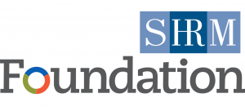
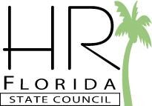
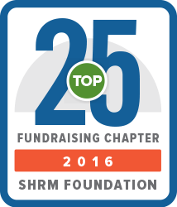
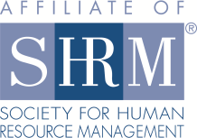
Proceeds from
the Silent Auction
are benefiting:

“SHRM Foundation maximizes the impact of the HR profession on organizational decision making and performance by promoting innovation, education, research and the use of research based knowledge.”
“Empowering families to achieve a better life through a full range of services, both directly and in collaboration with community partners, thus renewing hope & restoring lives back into the fabric of the community.”
For questions regarding the Silent Auction, contact the SHRM Foundation Director at foundation@shrmjax.org.

$4,094
Total money raised during the 2019 conference for the SHRM Foundation
Silent Auction to Benefit
the SHRM Foundation
Thank you for your contribution to our silent auction. Please complete this form and email to Chapter Management at chaptermgt@shrmjax.org or upload online when completing your registration/payment. If you have questions regarding the silent auction, please contact our SHRM Foundation Director at foundation@shrmjax.org.
Donor Name:
Organization Name:
Mailing Address:
City, State Zip
Primary Phone:
Alternative Contact:
E-mail:
Describe the item you are donating (Please be as descriptive as possible):
Approximate retail value: | $
Email this completed form to chaptermgt@shrmjax.org or upload online by
Tuesday, October 27th, 2020.
Thank you for your support!

